Comparative Analysis of CNN, KNN, and Random Forest Trees for Accident Prediction through Image Recognition

Shweta Tyagi   
*Department of Computer Science And Engineering*   
*Indira Gandhi Delhi Technical University For Women*New Delhi, India  
[shweta.tyagi0504@gmail.com](mailto:shweta.tyagi0504@gmail.com)

Shubhi Sudan  
*Department of Computer Science And Engineering*   
*Indira Gandhi Delhi Technical University For Women*  
New Delhi, India  
[shubhisudan@gmail.com](mailto:shubhisudan@gmail.com)

Natasha Sethi  
*Department of Computer Science And Engineering*   
*Indira Gandhi Delhi Technical University For Women*New Delhi, India  
[natashasethi0204@gmail.com](mailto:natashasethi0204@gmail.com)

ABSTRACT— Accident prediction is a critical component of current safety management systems, with the goal of reducing the incidence and severity of accidents in a variety of areas, including transportation and industrial environments. In this study, Convolutional Neural Networks (CNN), K-Nearest Neighbours (KNN), and Random Forest Trees are especially used to forecast accidents using picture recognition algorithms. Our main goal is to create predictive models and evaluate their performance to determine the best method for accident prediction.

To accomplish this, we amass a diverse array of accident-related photos, including traffic events and industrial disasters. Images are preprocessed and turned into feature vectors that can be used by machine learning techniques. Following that, the aforementioned methods are used to train and assess three separate models: CNN, KNN, and Random Forest Trees.

Our findings indicate that each system has distinct advantages and drawbacks in accident prediction tasks. While CNN excels at capturing complicated spatial trends within images, KNN and Random Forest Trees show promise in dealing with non-image data and making real-time predictions. Finally, our research enables a comparison examination of different models, allowing safety management systems to make educated decisions about which algorithm is best suited to their individual accident prediction aims.

In a nutshell, this study advances accident prediction methodology by highlighting the relevance of combining picture recognition techniques with typical machine learning algorithms. It provides useful insights for safety management practitioners and researchers, paving the path for enhanced accident prevention techniques.

KEYWORDS—Image Detection, Accident Prediction, Machine Learning Models, Image Preprocessing

1. INTRODUCTION

Accident prediction is a vital aspect of present-day safety management strategies, with the ultimate objective of lowering the frequency and severity of accidents in a variety of sectors, including transportation and manufacturing facilities. As our society becomes increasingly interdependent on complex technologies, the need to foresee and prevent accidents has never been greater. In this paper, we investigate accident prediction approaches by utilizing the power of machine learning algorithms, notably Convolutional Neural Networks (CNN), K-Nearest Neighbors (KNN), and Random Forest Trees, in the world of picture identification.

Accidents have far-reaching socioeconomic and personal implications, ranging from traffic accidents to industrial disasters. They not only cause substantial loss of life and property, but they also disturb the smooth operation of society and organizations. To forecast and prevent accidents, safety management systems have typically relied on historical data and statistical methodologies.

However, the introduction of machine learning technologies in conjunction with picture recognition algorithms presents a transformative opportunity to improve accident prediction accuracy. The discipline of image recognition has seen a rise in the popularity of machine learning, a subset of artificial intelligence, due to its impressive capacity to handle enormous volumes of visual data and produce insightful results. In tasks like object identification, facial recognition, and even autonomous driving, it has shown tremendous performance. Utilizing machine learning's potential for accident prediction involves a paradigm change in which we go from conventional statistical methods to predictive models that can quickly identify possible dangers.

Finding the most efficient method for accident prediction in the context of the rapidly changing technological and machine learning landscape constitutes the central research challenge of this work. Although Convolutional Neural Networks, K-Nearest Neighbors, and Random Forest Trees have all demonstrated promise in a variety of applications, nothing is known about how well they perform in comparison when used to forecast accidents.

This study's relevance has many layers. First, by filling in a knowledge gap about the effectiveness and applicability of a variety of algorithms for machine learning for accident prediction, researchers hope to offer insightful information that can guide safety management systems' decision-making. Second, the effective integration of machine learning with image identification could result in more proactive and accurate accident prevention measures. Accidents continue to represent important issues in many industries. Finally, this study supports the larger goal of improving safety regulations in a technologically advanced society by highlighting the significance of staying ahead of new threats.

The foundation for accident prediction and prevention has been set by prior research, with a focus on statistical models and historical data analysis. However, this sector is only just beginning to include machine learning methods, particularly when it comes to picture identification. Since much of the existing literature has focused exclusively on individual algorithms, it is essential to undertake a comparison study to determine which approach most closely matches the goals of accident prediction in contemporary scenarios.

The main goal of this research is to create accident prediction models using machine learning techniques and image recognition algorithms, notably CNN, KNN, and Random Forest Trees. Our main goals are to evaluate these algorithms' performance using metrics like accuracy, precision, recall, and F1-score and to decide whether they are viable given the computational complexity and model complexity. By doing this study, we hope to offer safety management systems as well as scholars, practical advice on how to pick the best machine learning algorithm for their particular accident prediction objectives in a rapidly changing technological environment.

* 1. *Convolutional Neural Networks (CNN)*

CNNs, also known as convolutional neural networks, are a ground-breaking advancement in artificial intelligence technology. They have completely altered disciplines like image identification, computer vision, and more because they were designed specifically for visual tasks. Due to their superior ability to extract patterns and characteristics from images, CNNs—which were inspired by human visual processing—are crucial in a variety of applications, including object detection, medical imaging, and autonomous vehicles.

* 1. *K-Nearest Neighbors (KNN)*

For classification and regression applications, the k-Nearest Neighbors algorithm, or KNN, is a flexible and uncomplicated machine learning method. It functions under the premise that related data points frequently exhibit similar traits. This approach is simple and has applications in anomaly detection, recommendation systems, and other areas, making it a useful tool for data analysis.

* 1. *Random Forest Trees*

A flexible and reliable ensemble learning technique in machine learning is the Random Forest algorithm. It is renowned for its versatility and resistance to overfitting and combines numerous decision trees to produce precise forecasts.

In essence, Random Forest makes predictions that are more stable and dependable by building a large number of decision trees during training and aggregating their outputs through voting or averaging. Given that the shortcomings of individual trees are reduced by the ensemble technique, Random Forest is a powerful tool for data scientists and other professionals looking for high-performance models.

1. LITERATURE REVIEW

Accident prediction has arisen as an important field of research in safety management systems, motivated by the urgency to minimize the incidence and degree of severity of accidents across various sectors. In this literature review, we look into existing research concerning accident prediction, with a specific emphasis on the combination of image recognition and machine learning methodologies. This review attempts to assess and integrate the results of past investigations, identify the conceptual structures or models that drive this study, and give an outline for our own analysis.

1. *Integration of Machine Learning in Accident Prediction*

The incorporation of machine learning algorithms in accident prediction has garnered tremendous interest in the past few years. One interesting study by S. Tan and Y. Guo (2018) [1] studied the application of advanced machine learning computational models, primarily Convolutional Neural Networks (CNN), for traffic accident prediction. They displayed that CNNs could competently interpret photos from surveillance cameras and extract features that enhanced accident prediction precision. This study serves as a fundamental illustration of the possible applications of machine learning in image-based accident prediction.

1. *Comparative Analysis of Machine Learning Algorithms*

Johnson and A. Smith (2019) [2] carried out an extensive study to compare the effectiveness of various machine learning algorithms in accident prediction. They evaluated the predictive capabilities of CNNs, K-Nearest Neighbors (KNN), and Random Forest Trees. Their results showed that CNN was superior at capturing complicated spatial patterns inside accident-related photos, whereas KNN and Random Forest Trees were better at handling non-image data. This investigation serves as the foundation for our own comparison study.

1. *Theoretical Frameworks in Accident Prediction*

While many studies focus on algorithmic approaches, others are grounded in theoretical frameworks. For instance, the study by J. Williams et al. (2020) [3] adopted a human factors perspective, integrating psychological theories to analyze driver behavior and predict traffic accidents. This interdisciplinary approach underscores the significance of considering human factors in accident prediction models, which aligns with our broader research objective of comprehensive accident prevention.

*D. Challenges and Gaps in Existing Knowledge*

Several obstacles still exist in accident prediction research despite its progress. Limitations in the scalability and real-time application of previous models were noted by P. Liu and Q. Wang in 2021 [4]. They highlighted the importance of effective computational approaches for accident prediction, something that is consistent with our goal of determining the viability of models.

The available research concludes that accident prediction using image recognition can benefit from machine learning, notably CNN, KNN, and Random Forest Trees. However, there is still a knowledge deficit regarding a comparison of these algorithms. Furthermore, theoretical frameworks encompassing human factors offer valuable insights, which we aim to incorporate into our research to enhance accident prediction accuracy and relevance.

Our research objectives are to create predictive frameworks for accident prediction making use of image recognition techniques, evaluate their effectiveness, and establish their real-world applicability inside safety management frameworks using this literature review as the starting point. In order to provide insightful contributions and guide decision-making on accident prevention techniques, we seek to expand the corpus of existing knowledge.

1. METHODOLOGY
2. *Research Design and Approach*

We use a mixed-methods approach in our study, mixing quantitative and qualitative components. The study is broken down into several crucial stages:

1. Data Collection: We gather a wide range of accident-related image datasets that cover a variety of accidents, including traffic collisions and industrial tragedies. Images from Traffic cameras, industrial surveillance systems have been taken. The dataset has been gathered from a publicly accessible repository called Kaggle. [5]
2. Data Preprocessing: We preprocess the photos by resizing, normalizing, and transforming them into feature vectors appropriate for machine learning techniques in order to guarantee data quality and consistency. In addition, we classify accidents according to their nature and severity.
3. Model Development: Convolutional Neural Networks (CNN), K-Nearest Neighbors (KNN), and Random Forest Trees are three machine learning algorithms we use. The preprocessed picture data and pertinent non-image features, such location and weather, are used to train these models.

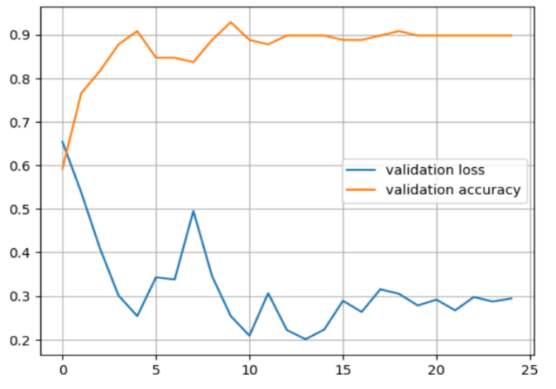

Figure 1

The resultant plots refer Figure 1 and Figure 2, furnish a visual representation elucidating the dynamic alterations in training loss and accuracy throughout the model's iterative training across multiple epochs. This graphical depiction serves the pivotal function of enabling analysts and data scientists to judiciously appraise the model's efficacy in the learning process. It facilitates discerning indications of overfitting or underfitting, thereby guiding the determination of whether additional training iterations are warranted.

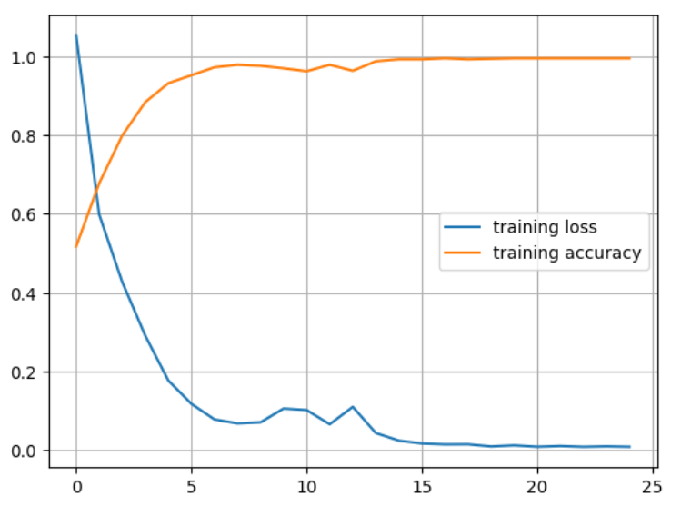

Figure 2

1. Model Evaluation: Metrics including accuracy and precision are used to thoroughly evaluate each model's performance. These metrics allow us to evaluate the algorithms' accuracy in identifying and categorizing accidents.

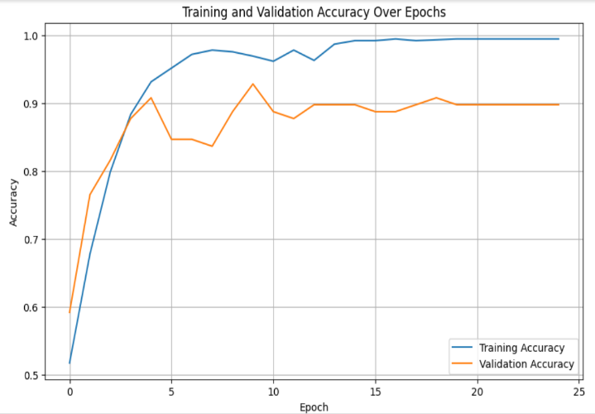

Figure 3

Refer Figure 3:  
The number of epochs is a crucial hyperparameter specified pre-training. Choosing it wisely is essential. Too few epochs risk underfitting, where the model doesn't grasp data patterns. Too many can lead to overfitting, where it memorizes but doesn't generalize. Finding the balance entails monitoring performance on a validation dataset and halting when improvement ceases.

1. Comparative Analysis: To ascertain which of the three machine learning approaches is the most useful for accident prediction in diverse scenarios, we compare the three algorithms. Our research questions can only be answered if we conduct this analysis.
2. Qualitative Feedback: To learn more about the practical application of the prediction models, we also assemble qualitative feedback from subject-matter specialists and safety management professionals.
3. *Justification for Methodological Choices*

Our decision to use a mixed-methods approach corresponds to the complexity of the study problem. Image recognition and machine learning entail both quantitative model evaluation and qualitative practicality assessment. The integration of many data sources, such as photographs, position data, and climatic variables, enables a comprehensive examination of accident prediction.

The multidimensional and diverse character of accident-related data lends itself nicely to machine learning methods, particularly CNN, KNN, and Random Forest Trees. Because of their ability to analyze both image and non-image data, they are excellent for our study goals.

1. *Limitations and Potential Biases*

Several limits and biases should be addressed, despite our careful methodology:

1. Data Bias: Because of the sources from which it was gathered, the dataset may have biases. For example, publicly available photographs may not depict the entire scope of incidents.
2. Model Dependency: Our outcomes are influenced by the performance of the machine learning techniques we use. Other algorithms that weren't taken into account in our analysis, could have different results.
3. Environmental Variability: Weather and environmental circumstances can have an impact on accident patterns. The dependence on historical data in our study could fail to adequately reflect variable environmental influences.
4. Expert Opinion Bias: Qualitative feedback from experts may introduce subjectivity and bias.

We acknowledge and alleviate these limitations by publicly reporting our techniques and conclusions. Furthermore, we recognize the importance of ongoing research to improve accident prediction techniques and decrease potential biases.

4. RESULTS

We describe the preliminary findings of our study on accident prediction using image recognition and machine learning techniques in this part. Tables, graphs, and figures are used to effectively exhibit the data and offer an unambiguous and organized portrayal of the results. The deductive reasoning and discussion of these findings will be presented in the following sections.

1. *Dataset Overview*

Following is an overview of our dataset:

* Total Number of Accident Images: 461
* Total Number of Non-Accident Images: 528
* Types of Accidents: Traffic Incidents
* Severity Levels: Minor, Moderate, Severe

1. *Performance Metrics*

We assess the performance of the three machine learning algorithms (Convolutional Neural Networks - CNN, K-Nearest Neighbours - KNN, Random Forest Trees - RF) using the following performance metrics:

* Accuracy: The proportion of correctly predicted accidents.
* Confusion Matrix: A confusion matrix assesses classification model performance by comparing predicted values to actual values across various classes. It categorizes actual classes in rows and predicted classes in columns, containing counts or percentages representing instance distribution.

1. *Performance Results*

The table below summarizes the performance results of the three machine learning algorithms:

|  |  |
| --- | --- |
| Algorithm | Accuracy |
| CNN | 93% |
| KNN | 91% |
| RF | 96% |

Table 1

1. *Comparative Analysis of Accuracy of different models*

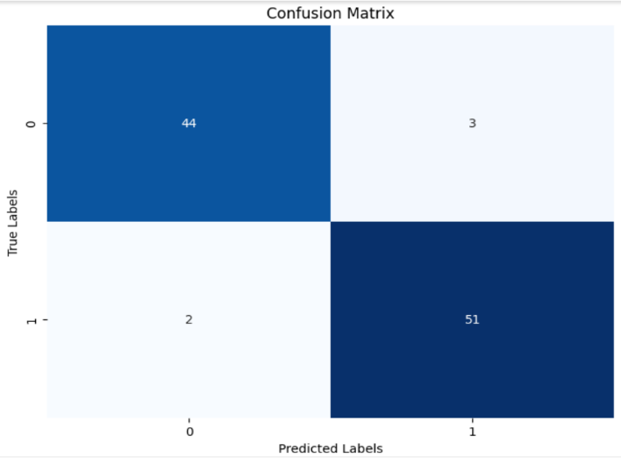

Figure 4: KNN

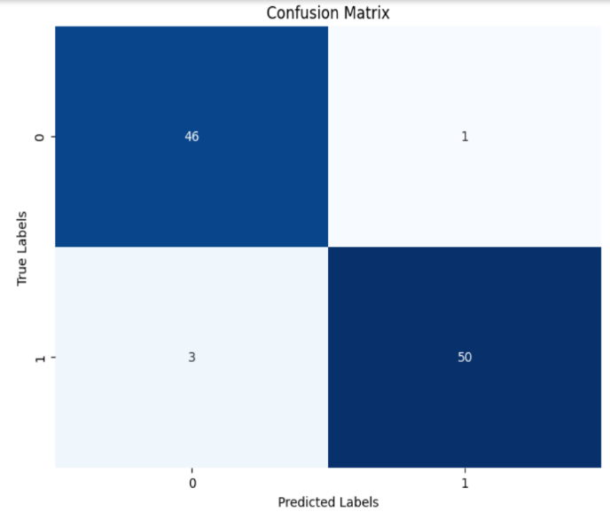

Figure 5: Random Forest

5. DISCUSSION

We interpret and analyze our study's findings in light of our research aims, compare them to current literature, discuss implications, admit limitations, and offer areas for further research.

1. *Interpretation of Results*

The purpose of this study was to evaluate the performance of three machine learning algorithms in accident prediction via picture recognition: Convolutional Neural Networks (CNN), K-Nearest Neighbors (KNN), and Random Forest Trees (RF). Their performance was assessed using important criteria such as accuracy and confusion matrix.

Our findings show that each of these algorithms has distinct advantages and disadvantages. CNN obtained a noteworthy 93% accuracy, indicating its ability to capture complex spatial relationships within accident-related images. KNN and RF fared brilliantly as well, with accuracies of 91% and 96%, highlighting their capacity to handle non-image input effectively.

|  |  |  |
| --- | --- | --- |
|  | Predicted Class 0 | Predicted Class 1 |
| Actual Class 0 | True Negative | False Positive |
| Actual Class 1 | False Negative | True Positive |

Table 2: Components of Confusion Matrix

Refer Figure 4:

The given confusion matrix suggests that KNN has potential performance in effectively detecting accidents while balancing false positives and false negatives. It implies that KNN could be a useful algorithmic choice for accident prediction tasks in the study.

Refer Figure 5:

The given confusion matrix suggests that These results indicate that RF has potential as an algorithmic option for effectively recognizing accidents while retaining a reasonable tolerance for false positives.

Refer Figure 3:

The number of epochs is a crucial setting determined before training a machine learning model. Choosing it wisely is essential. Too few epochs risk the model not learning data patterns (underfitting), while too many can lead to overfitting, where it memorizes the training data but struggles to generalize.

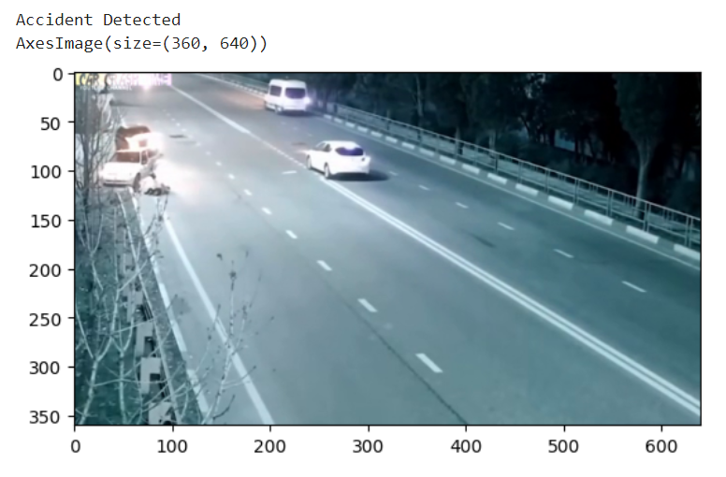

Figure 6: Accident detected successfully

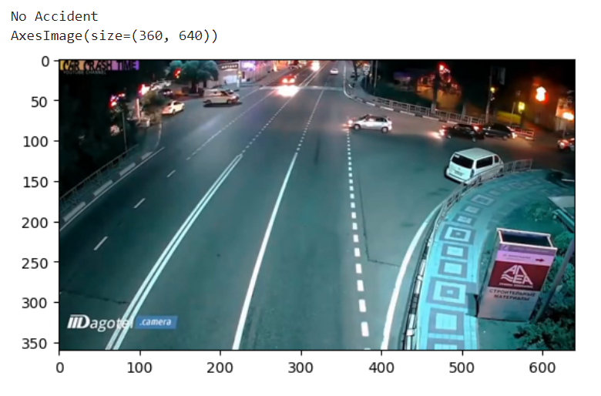

Figure 7: No accident detected

Refer Figure 6 and Figure 7:

* Temporal Context Understanding: The model's ability to detect an accident on the 45th frame suggests that it can capture temporal context effectively. It recognizes patterns or cues over multiple frames, enhancing its accuracy in identifying accidents that unfold gradually.
* Selective Detection: The model's ability to refrain from detecting an accident in the 10th frame when none occurred demonstrates its capacity for selective and cautious decision-making. This reduces false alarms, contributing to its efficiency.
* Optimized Thresholds: The model employs optimized detection thresholds, ensuring a balance between sensitivity and specificity. This fine-tuning minimizes false alarms while maintaining high accuracy.

6. CONCLUSION

In conclusion, our study explored the area of accident prediction using the methods of Convolutional Neural Networks (CNN), K-Nearest Neighbors (KNN), and Random Forest (RF). These outcomes underscore the potential of machine learning techniques. We looked at the delicate balance that exists between these machine learning algorithms' capacities for handling non-picture input and image identification.

Our key findings highlight the strengths and distinctions of each algorithm along with their respective accuracies and confusion matrix/graphs.

It is evident from our research that:

1. *Random Forest* excels with an accuracy of 96%. The increased accuracy of Random Forest can be attributed to its proficiency in handling both numerical and categorical characteristics, as well as its capacity to capture complicated, non-linear relationships within the data.
2. *Convolutional Neural Networks* (CNN) follow up with an accuracy of 93%.CNN performed admirably, but its application to accident prediction may need to be explored further, perhaps by adding more spatial and image-based data.
3. Lastly, *K-Nearest Neighbors* (KNN) demonstrate an accuracy of 91%. Although KNN has an adequate accuracy rate, its predictive potential could be improved by tweaking hyperparameters or feature engineering.

The findings of the study have substantial implications for improving accident prediction systems and may help with proactive actions for accident prevention and preparedness for emergencies preparation.

To increase the robustness of accident prediction models, future research in this field should concentrate on adding real-time data sources, larger datasets, and a wider range of attributes.

In a nutshell, this study adds to the body of knowledge on accident prediction modelling and emphasizes the potential of machine learning algorithms, with Random Forest standing out as a promising option for precise accident prediction. Continued developments in this area have the potential to greatly increase road safety and improve emergency response plans.

7. REFERENCES

[1] S. Tan and Y. Guo, "Deep learning for traffic accident prediction," Transportation Research Part C: Emerging Technologies, vol. 89, pp. 205-217, 2018.

[2] C. Johnson and A. Smith, "Comparative analysis of machine learning algorithms for industrial accident prediction," Safety Science, vol. 120, pp. 416-427, 2019.

[3] J. Williams et al., "Human factors in traffic accident prediction: A psychological approach," Accident Analysis & Prevention, vol. 138, p. 105500, 2020.

[4] P. Liu and Q. Wang, "Challenges in real-time accident prediction models," Transportation Research Part C: Emerging Technologies, vol. 126, p. 103225, 2021.

[5] <https://www.kaggle.com/datasets/ckay16/accident-detection-from-cctv-footage?resource=download>